Student Name: Click here to enter text.
Access Code (located on the lid of your lab kit): Click here to enter text.
Pre-Lab Questions
”1. Name two functions of the nasal cavity mucosa.”
To humidify the air
To catch particles
”2. Why is the trachea reinforced with cartilaginous rings? ”
To allow the trachea to collapse slightly so that food can pass down the esophagus. This structures are put in place because of the negative air pressure.
”3. Describe the path a molecule of oxygen takes to get to body tissue, starting with the nares. ”
The O2 molecule enters into the nares and gets warmed and hydrated by the mucus. It then passess through via the trachea and into the bronchi. The bronchial tubes continue to split lesser and lesser until oxygen is aborbed through diffusion
”4. What is asthma? ”
This is the constriction of the bronchial tubes not allowing air to continue passing into the smaller tubes for absorption.
Experiment 1: Microscopic Anatomy of the Respiratory System
Table 1: Experimental Observations
Respiratory Image | Description of Visible Structure(s)
Trachea | Columnar cells
Lung | Bronchiole

Post-Lab Questions
”1. Label the arrows in the slide images below. ”
A- columnar cell
B- Basement membrane
C- Lamina propia connective tissue
D- Cilia
E- Bronchioles
F- Bronchi
G- Alveolar sac
H- Alveoli
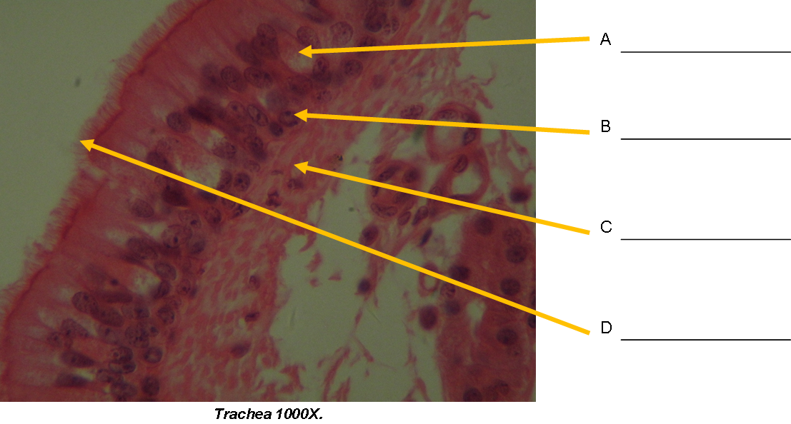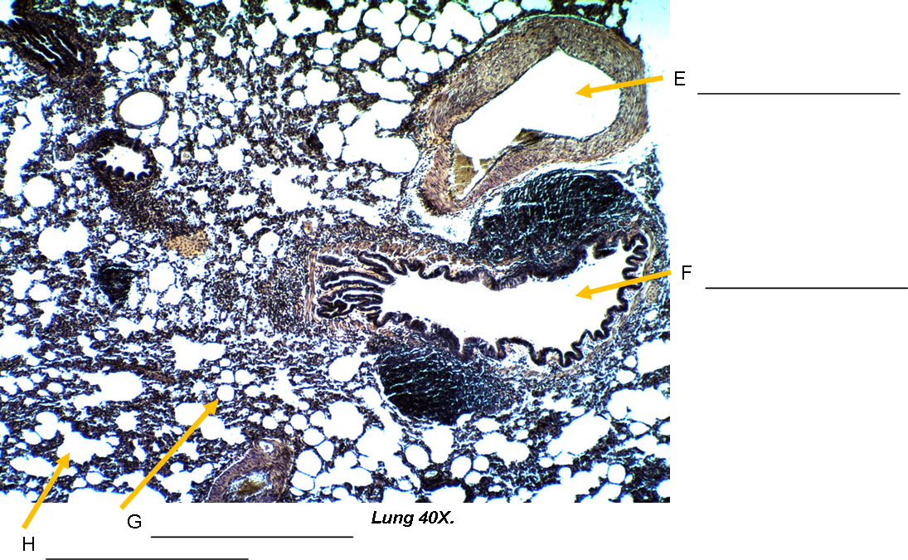

”2. What structural features of alveoli make them an ideal place for gas exchange? ”
Thin walls and large surface area
”3. Why is mucus present in the trachea? ”
Its purpose is to trap debris in inhaled air purifying it for the lungs
”4. What is the specific function of the cilia on the walls of the trachea? ”
Cilia filters unwanted particles and hence removes them

Experiment 2: Virtual Model – The Respiratory System
”1. How many diaphragm(s) exist in the human body? ”
One diaphragm
”2. Does deoxygenated blood become oxygenated in the upper respiratory tract, the lungs, or the diaphragm? ”
The Lungs
”3. Is the trachea superior or inferior to the diaphragm? ”
Superior
”4. Is the heart (located in the mediastinum) or the right lung more medial to the body? ”
Mediastinum
”5. What is the most inferiorly located organ of the respiratory system? ”
The lungs
Experiment 3: Virtual Model – Respiratory System Coloring Activity
”Insert Respiratory System – Anterior View image here: ”

Experiment 4: Understanding Lung Mechanics
Table 2: Understanding Lung Mechanics Observations
Squeezed Bottle Observations (Step 3) | Released Bottle Observations (Step 4)
Held upright since it was full | Deflation

Post-Lab Questions
”1. What happens to the balloon? Why? ”
The balloon expanded as the air pressure from the bottle reduced and deflated as air went away from the balloon and back into the bottle; through the mechanism of how air is released from the lungs
”2. What would happen if the seal at the base of the bottle leaked? ”
The air would go through that leak hole and not through the balloon
”3. What causes a collapsed lung? ”
A hole in the lungs or any kind of a rupture
”4. Is a collapsed lung functional? Why or why not? ”
Because they is no negative air pressure, the collapsed lund would not be functional hence no deflation or inflation.
Experiment 5: Peak Flow Meter
Table 3: Peak Flow Meter Data
Trial | Normal | Post-Exercise
1 | 290 | 355
2 | 270 | 395
3 | 305 | 405
Highest Reading | 305 | 405
Post-Lab Questions
”1. What changes were observed after the volunteer exercised? ”
After a voluntary exercise, I realized that his sweat increased as breathing became harder and more rapidly.
”2. Did the PEF increase or decrease? Explain why this change occurred; be sure to incorporate physiological reasoning in your explanation. ”
It decreased since the amount of O2 in lungs was less leading to a fast rate breathing
Experiment 6: Fetal Pit Dissection: The Respiratory System
Post-Lab Questions
”1. Describe the interior lining of the trachea. ”
The interior linings contains cilia long with ciliated columnar epithelium which apparently makes up the lining
”2. What role do the rings of cartilage surrounding the trachea play? ”
The rings of the cartilage surrounding the trachea prevents the trachea from developing any harm as since it is able to constrict blocking passageways.
”3. Were there many or few vessels serving as conduits between the lungs and the heart? Why is this important? ”
Yes. This is because of oxygenated blood has to flow requiring many blood vessels between the lungs and the heart
”4. Describe the function of the diaphragm during inhalation and exhalation. ”
During inhalation, the diaphragm functions too contract compeling the thoracic cavity to expand bringing in oxygen. In exhalation, the diaphragm relaxes reducing the thoracic cavity releasing oxygen to other body organs.

”Insert photo of your pig’s exposed lungs with your name clearly visible in the background: ”

